29. Design DFA using simulator to accept the input string “bc” ,”c”,and ”bcaaa

INPUT:

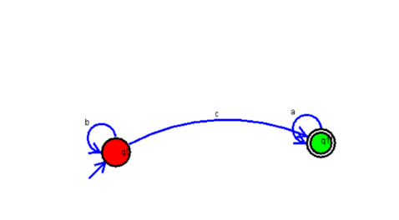

OUTPUT:

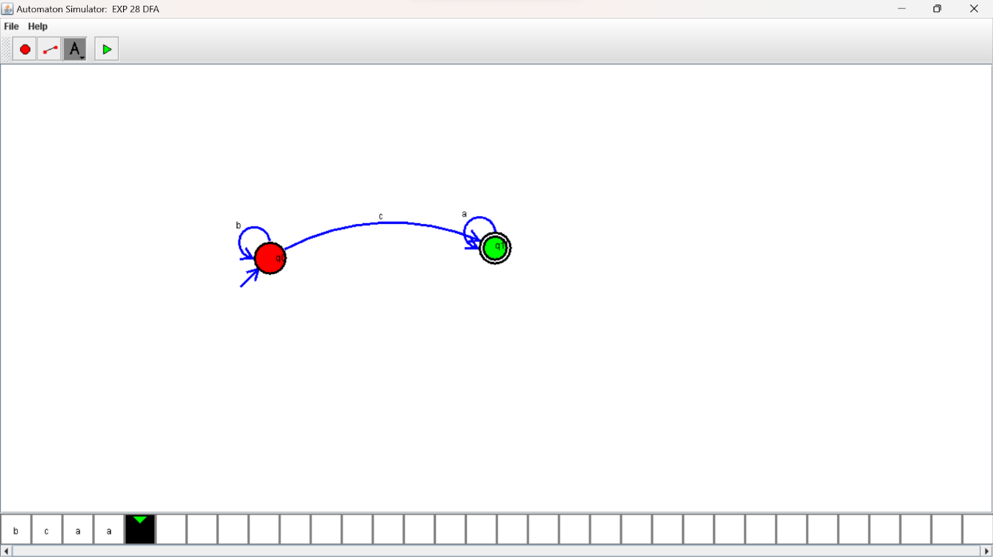

RESULTS:

Design DFA using simulator to accept the input string “bc” ,”c”,and ”bcaaa